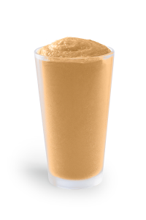**Calories – ???**

**Fat - ?g**

**Protein - ?g**

**Carbohydrates - ?g**

**Fiber - ?g**

**Sugar - ?g**

**Banana Smoothie**

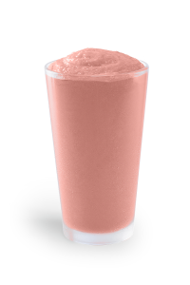

**Calories – ???**

**Fat - ?g**

**Protein - ?g**

**Carbohydrates - ?g**

**Fiber - ?g**

**Sugar - ?g**

**Strawberry-Banana Smoothie**

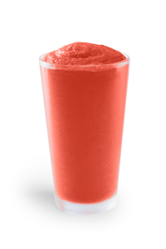

**Calories – ???**

**Fat - ?g**

**Protein - ?g**

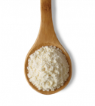**Carbohydrates - ?g**

**Fiber - ?g**

**Sugar - ?g**

**Strawberry Protein Smoothie**

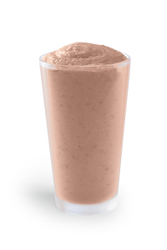**Calories – ???**

**Fat - ?g**

**Protein - ?g**

**Carbohydrates - ?g**

**Fiber - ?g**

**Sugar - ?g**

**Apple Smoothie**

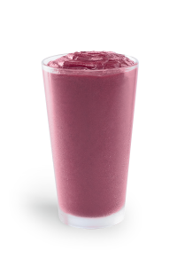

**Calories – ???**

**Fat - ?g**

**Protein - ?g**

**Carbohydrates - ?g**

**Fiber - ?g**

**Sugar - ?g**

**Triple-Berry Smoothie**

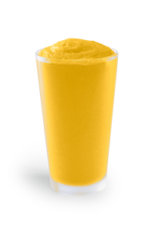

**Calories – ???**

**Fat - ?g**

**Protein - ?g**

**Carbohydrates - ?g**

**Fiber - ?g**

**Sugar - ?g**

**Mango Smoothie**

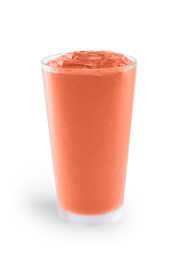**Calories – ???**

**Fat - ?g**

**Protein - ?g**

**Carbohydrates - ?g**

**Fiber - ?g**

**Sugar - ?g**

**Peach Smoothie**

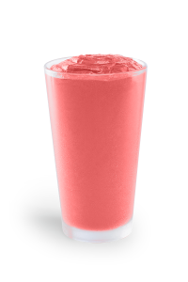

**Calories – ???**

**Fat - ?g**

**Protein - ?g**

**Carbohydrates - ?g**

**Fiber - ?g**

**Sugar - ?g**

**Watermelon Smoothie**

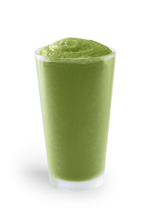

**Calories – ???**

**Fat - ?g**

**Protein - ?g**

**Carbohydrates - ?g**

**Fiber - ?g**

**Sugar - ?g**

**Keto Smoothie**

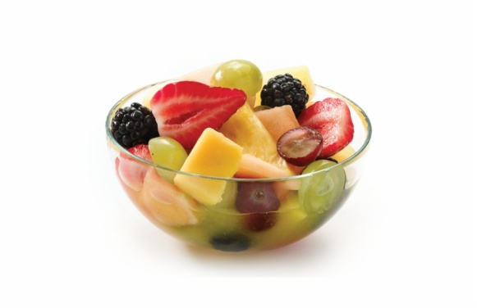**Calories – ???**

**Fat - ?g**

**Protein - ?g**

**Carbohydrates - ?g**

**Fiber - ?g**

**Sugar - ?g**

**Fruit Cups**